Oklahoma Forestry Association Membership Application
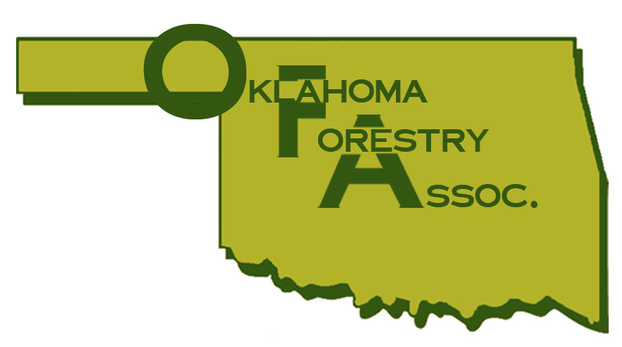

Activities of the Oklahoma Forestry Association

- Sponsors State 4H and FFA Forestry Contest
- Sponsors Annual Youth Forestry and Wildlife Camp
- Organizes Programs to Train Loggers in Best Management Practices
- Monitors State and Federal Legislation That Affect Forest Industry and Forest Landowner
- Provides Information as Requested About Forest Practices and Operations
- Promotes Cooperation Between State, Federal, and Private Forest Interest
- Sponsors and Supports “THE AMERICAN TREE FARM SYSTEM” A Program Providing Free Professional Forest Management to Landowners
- Sponsors and Supports LOG-A-LOAD FOR KIDS Raising $5230 in 2004, $3061 in 2005, $4490 in 2006, and $3850 in 2007
- Sponsors “Project Learning Tree”
- Sponsors “Annual Forestry Utilization Expo”
- Sponsors “Arson/Vandalism” Reward Program

Membership (check one)

- Individual - $25 annually
- Individual Lifetime - $500
- Financial Institutions - $200 annually
- Associations and Clubs - $50 annually
- Contractors - $100 annually
- Consultants - $100 annually
- Students - $10 annually

Non-Industrial Private Landowner

- 1-320 acres - $25 annually
- 321-640 acres - $50 annually
- 641-999 acres - $75 annually
- 1000 acres + - $100 annually
- Forest Industry/Corporate Landowner $500 annually

All dues are considered on a minimum basis. Your membership +50% is considered a Silver membership, + 100% is considered a Gold Membership, and your membership +200% are considered Platinum Memberships.

Renew your membership today by providing the information above and remitting the appropriate payment to the address below. Members receive regular newsletters and briefings on current activities. Make checks payable to:

OKLAHOMA FORESTRY ASSOCIATION
P.O. Box 238
Idabel, OK 74745
Trees for People
